You can choose to submit either A2 (worth 150 points), AD2 (worth 180), or both (worth 180) for this assignment you will get a score for the assignment either 150 points base or 180 points base.

A2
Create a class called employee.
- It should includes three instance variables
  - a first name (type String), a last name (type String) and a monthly Salary (double).
- Provide a constructor that initializes the three instance variables; provide a set and a get method for each instance variable.
  - If the monthly salary is not positive, display the inputted salary and set the salary to a $1,000 value.
Write test app named EmployeeTest that demonstrates class Employee’s capabilities.
- Create three employee objects with the following information.
  - Bob Jones, monthly salary $2875.00
  - Susan Baker, monthly salary $3150.75
  - John Lin, monthly salary -$5000.00
- Display each object’s yearly salary.
- Then give each Employee a 10% raise.
- Display each Employee’s yearly salary again.
You can find the needed techniques in chapter 1~ 5. You can also use more advance skills to do this assignment.
The CISP401V11A2.zip includes two files (Employee.class and EmployeeTest.class.) The Employee.class and EmployeeTest.class files are executable files. You can place Employee.class and EmployeeTest.class in a sub folder (directory). Bring up a command prompt and go to the sub directory, type “java EmployeeTest“ in the sub directory and hit “Enter” key. You should see the program run and should generate the same output as the following picture.

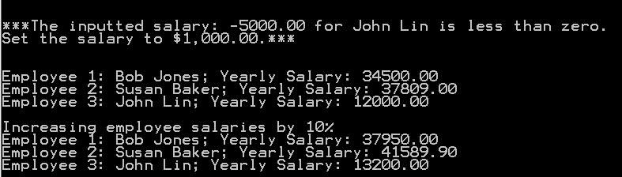

Before you submit your program please document your files properly and zip your .java files into a proper named zip file for an assignment (refer to the assignment section of the class syllabus) and submit it to the A2 folder of the Canvas Website.
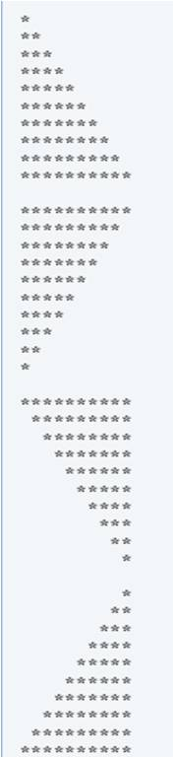
Worth 150 points

AD2
Write an application that will repeatedly display a choice menu for end users until a number 4 is entered.
The menu options should look like the following
Draw Triangles and Diamond shapes
Enter 1 to draw four separate triangles
Enter 2 to draw four triangle at the same row
Enter 3 to draw a diamond
Enter 4 to exit the program

If 1 is entered please use for loops to generate the patterns on the right. All asterisks (*) should be printed by a single statement of the form System.out.print( '*' );. (This statement causes the asterisks to print side by side.) A statement of the form System.out.println(); can be used to position to the next line. A statement of the form System.out.print( ' ' ); can be used to display a space for the last two patterns. There should be no other output statements in the program.

If 2 is entered that will prints all four patterns side by side in the command window.
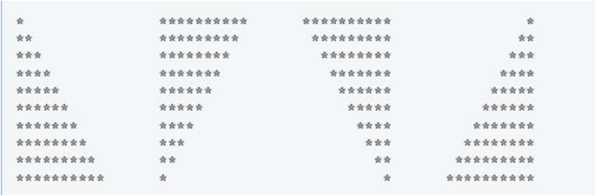
If 3 is entered the command window will display to read an odd number in the range 1 to 19 to specify the number of rows in the diamond. The program should then display a diamond of the appropriate size in the command window.
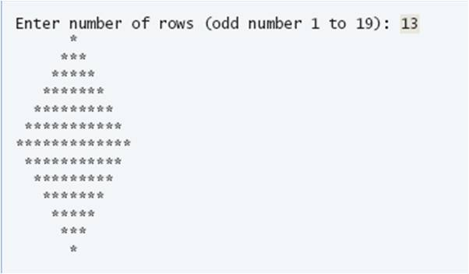
If not odd number or out of range number is entered the program should display an error information.

If 4 is enter that program will display "Thanks to use this program" in the command window. And the program should exit properly.

If other than 1, 2, 3, or 4 is enter that program will display "Invalid value entered" in the command windows.

In this program you have to provide three different classes to do each of the choice.

The following are some pictures of the program
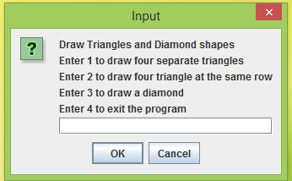  When the program starts we should see a Input dialog box as the picture on the above. | 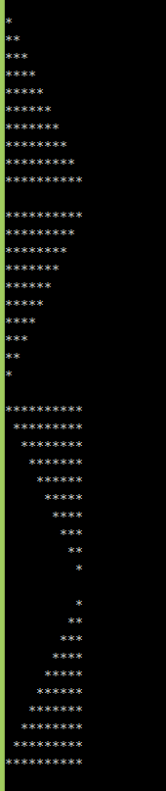  When we enter 1 in the input dialog box we should see a display in the command prompt as the left side of picture and then the input dialog box will display again.
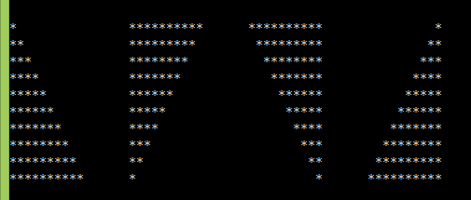When we enter 2 in the input dialogbox we should see a display in the command prompt as the picture above and then the input dialog box will display again.
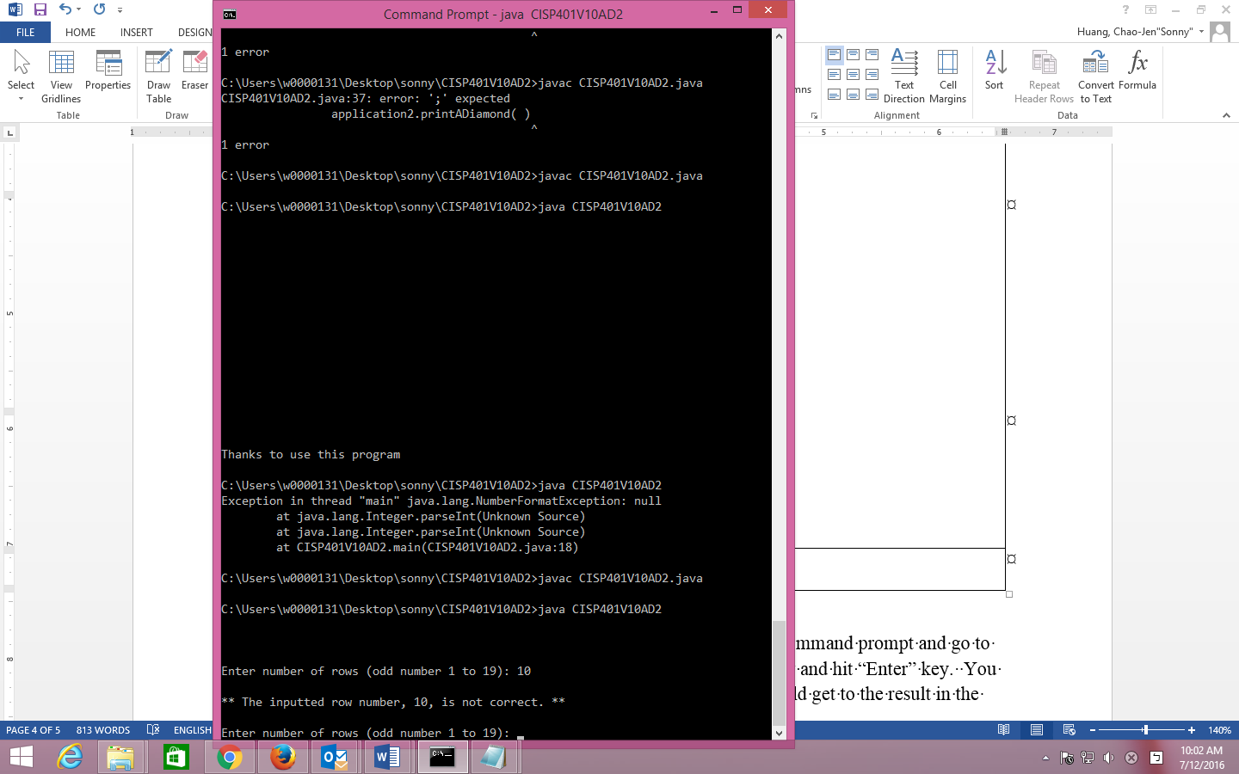
When we enter 3 in the input dialogbox we should see a display in the command prompt as the picture above.
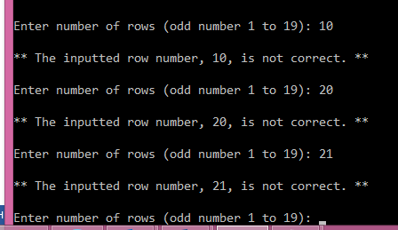  When the program requests to enter number of rows for drawing a diamond if we input any number other than odd number in between 1 and 19, the program will give the user a chance to input a proper odd number in between 1 and 19. | 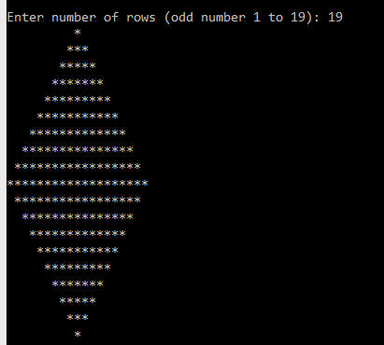  If we input number 19 at the request of number of rows we should see a display in the command prompt as the picture above and then the input dialog box will display again.
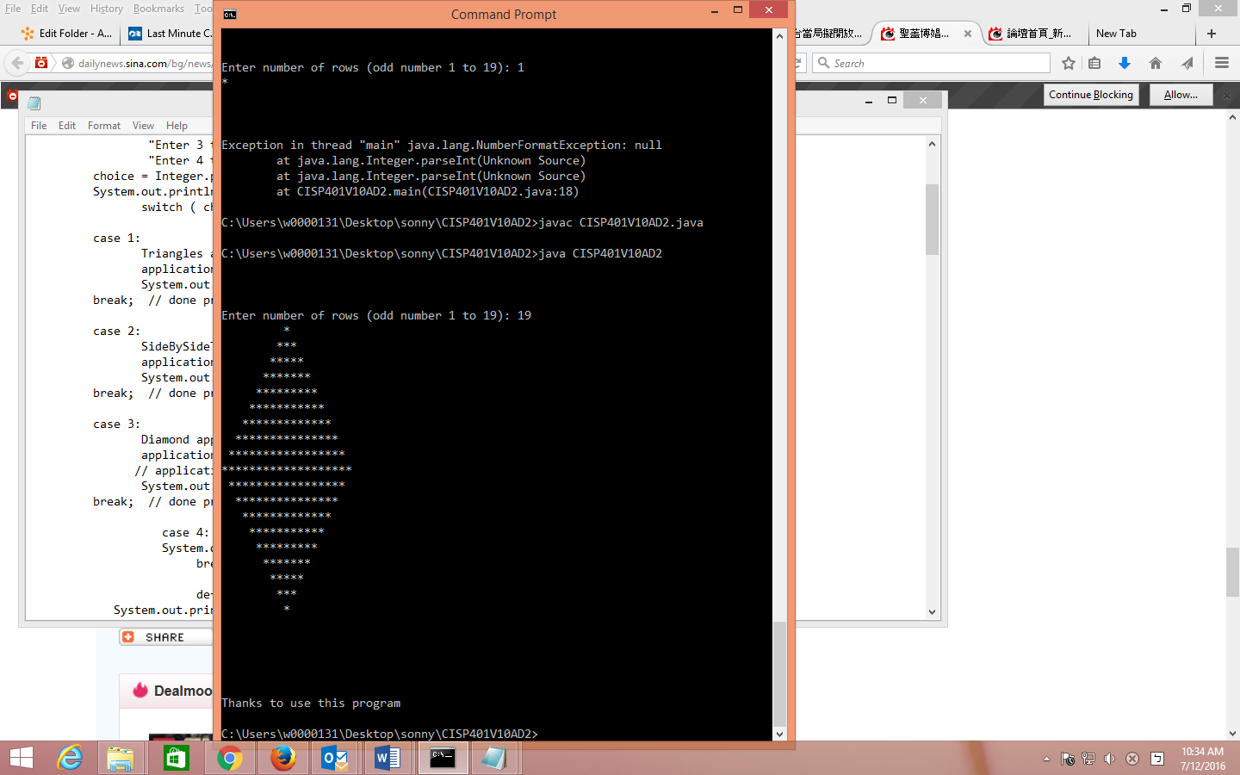  When we enter 4 in the input dialogbox we should see a display in the command prompt as the picture above. | 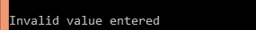  When we enter any number other than 1~4 in the input dialogbox we should see a display in the command prompt as the picture above and then the input dialog box will display again..

You can fine the needed techniques in chapter 1~ 5. You can also use more advance skills to do this assignment.
This assignment comes with a CISP401V11AD2.zip file. It includes four files (CISP401V11AD2.class, Diamond.class, SideBySideTriangles.class, and Triangles.class). All the .class files are executable files. .

You can place all the four files in a sub folder (directory). Bring up a command prompt and go to the sub directory, type “java CISP401V11AD2“ in the sub directory and hit “Enter” key. You should see the program run. If you put in proper information you should get to the result in the above pictures.

Please document the files properly and zip your .java files into a proper named zip file for an advance assignment (refer to the assignment section of the class syllabus) and submit it to the A2 folder of the Canvas Website.

Worth 180 points

